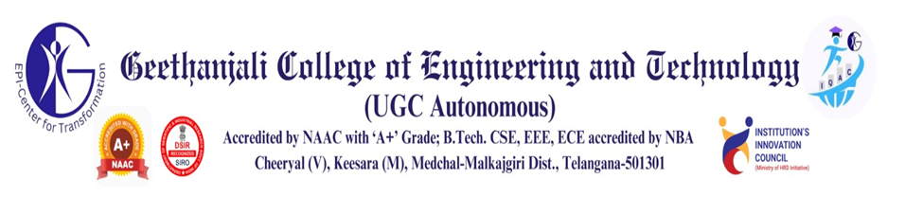
Department of Computer Science and Engineering
Guest Lectures Organized for A.Y 2025-26 I Semester
S. No | Name of the Resource person | Designation and Organization | Topic covered | Target Attendance | Proposed by (Name of the faculty)
1 | Dr.G Rajavikram | Head of CSE Department and Dean – School of Computing, Vignan Institute of Technology and Science Hyderabad | Object Oriented Programming – Java 8+ Features  On  17-09-2025 (1-Day) | B. Tech. CSE II Year I Sem. Students  (159) | Dr. M Srinivas  Mrs. P Lalitha
2 | Mr. P Mohan, | Sr. Data Scientist, Tech Mahindra, Hyderabad | Big Data Analytics – Apache Spark  On  18-09-2025 (1-Day) | B. Tech. CSE VI Year I Sem. Students  (164) | Dr. M Srinivas  Mrs. P Lalitha
3 | Dr D. Teja Santosh, | Professor, CSE, CVR Engineering College, Hyderabad | Artificial Intelligence – Ontological Engineering  On  20-09-2025 (1-day) | B. Tech. CSE III Year I Sem. Students  (154) | Dr. M Srinivas  Mrs. P Lalitha
4 | S V S P Sandeep Kumar, | Executive Director – Marketing & Projects, Ficus Realtime Pvt Ltd | Database Management Systems - MongoDB  On  17-10-2025 (1-Day) | B. Tech. CSE II Year I Sem. Students  (68) | Dr. M Srinivas  Mrs. P Lalitha
5 | Dr. Nikumani Choudhury | Assistant Professor, BITS, Hyderabad | Computer Networks – Data Center Networking On  22-10-2025 (1-Day) | B. Tech. CSE III Year I Sem. Students  (80) | Dr. M Srinivas  Mrs. P Lalitha
Coordinators
1. Dr. M. Srinivas, Associate Professor, CSE Department.
2. Mrs. P Lalitha, Sr. Assistant Professor, CSE Department.

Guest Lectures Organized for A.Y 2025-26 II Semester

S. No | Name of the Resource person | Designation and Organization | Topic covered | Target Attendance | Proposed by (Name of the faculty)
1 | Mr. M Srinivas | D365 Azure Devops Deployment Consultant,  Itineris, Hyderabad | Operating Systems – Virtualization and Cloud Computing  On  04-03-2026 (1-Day) | B. Tech. CSE II Year II Sem. Students  (155) | Dr. M Srinivas  Mrs. P Lalitha
2 | Mr. Sai Pavan Velidandla | Chief Technology  Officer, Brain O Vision Solutions India Private Ltd, Hyderabad | Web Technologies – MERN Stack  On  12-03-2026 (1-Day) | B. Tech. CSE II Year II Sem. Students  (109) | Dr. M Srinivas  Mrs. P Lalitha
3 | Dr. B Suresh Kumar | Software Engineer –II, Accellor Software Pvt. Ltd, Hyderabad | Agentic AI  On  13-03-2026 (1-day) | B. Tech. CSE III Year II Sem. Students  (186) | Dr. M Srinivas  Mrs. P Lalitha
4 | Mr. Venkatesh Rapolu | Team Lead / Application Architect at CSI Interfusion India Pvt Ltd,  Hyderabad | Web Technologies – React and Node JS  On  13-03-2026 (1-Day) | B. Tech. CSE II Year II Sem. Students  (257) | Dr. M Srinivas  Mrs. P Lalitha
5 | Dr. Apurba Das | Assistant Professor,  Department of Computer Science and Information Systems, BITS Pilani, Hyderabad. | Design and Analysis of Algorithms – Algorithms for Competitive Programming  On  06-04-2026 (1-Day) | B. Tech. CSE II Year II Sem. Students  (189) | Dr. M Srinivas  Mrs. M Swapna Rani
Coordinators
1. Dr. M. Srinivas, Associate Professor, CSE Department.
2. Mrs. M Swapna Rani. Assistant Professor, CSE Department.

